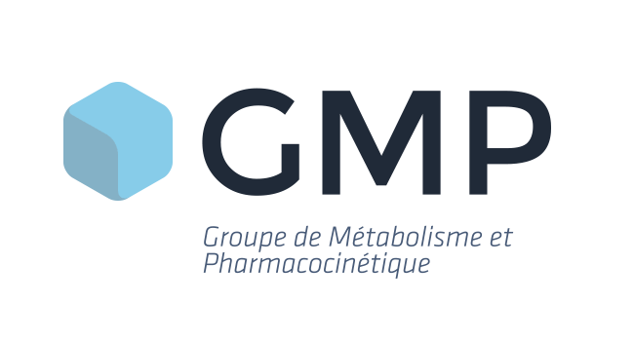

**2025 GMP symposium**

# SPONSORSHIP OPPORTUNITIES

Le Corum, Gentilly, France

15 -17 October 2025

The “**Groupe de Métabolisme et Pharmacocinétique**” (GMP, Group of Metabolism and Pharmacokinetics) is happy to announce sponsorship opportunities for its **2025 annual meeting**. The meeting will be held in **Gentilly** from 15th to 17th October 2025. The aim of the meeting is to produce a lively open discussion around the key topics of interest with delegates from a wide range of companies and groups from Europe. You will find additional information and the scientific program of the symposium regularly updated on the [GMP website](http://www.gmp.asso.fr/).

We offer **four sponsorship packages** to enable sponsors to fully participate in the meeting and the scientific discussion. When possible, we strongly encourage each sponsoring company to send scientists and students to attend: the delegate pass includes access to all the talks and the poster session.

**All sponsor levels offer the following opportunities:**

* Name and logo in conference papers
* Logo on GMP web site and rolling slides during the symposium
* Abstract and poster
* 250 words company profile in conference brochure (provided in an electronic format thru the GMP website)

## **SPONSORSHIP LEVELS**

|  |  |
| --- | --- |
| **SPONSOR LEVEL** | **CONTRIBUTION** |
| PLATINUM | From 5000 € |
| GOLD | From 3000 € |
| SILVER | From 1500 € |
| BRONZE | From 600 € |

Sponsorships below 600 € will not provide benefits to the sponsor but are still welcome!

Additional benefits are offered for higher sponsor levels:

## **BENEFITS TABLE**

|  |  |  |  |
| --- | --- | --- | --- |
| **BENEFITS** | **SILVER** | **GOLD** | **PLATINUM** |
| Free delegate place(s) | **1** | **1** | **2** |
| One exhibition space* | ü | ü | ü |
| Three-minutes company talk  at the end of a session(a) |  | ü | **ü** |
| 50% reduction fee for a student without poster (based on academic fees) |  | **ü** | **ü** |
| Specific sponsoring  (student scholarship, poster awards, coffee break, cocktail, paper notebook)(b) |  | **ü** | **ü** |

(a) First come, first served, limited number (**Platinum: GUARANTEED!**)

(b) First come, first served, limited number (**Platinum: priority until June 30st 2025**)

* Platinum and gold sponsors will be given the opportunity to choose the position of their exhibition space from a plan of the exhibition area according to the remaining availability at the time of signing up for sponsorship

**Start-up special offer!**

**Three-minutes company talk at the end of a session from the BRONZE level** (a)

*Start-up status to be validated by GMP board*

**!Special offers for Gold and Platinum sponsors!**

**To gain visibility during the symposium, you have the possibility to present your company in a 3-minutes talk at the end of a session and to benefit from a specific sponsoring**

*If you are interested, you can contact the GMP board for further information*



**2025 GMP MEETING**

# SPONSORSHIP OPPORTUNITIES

**Contact name:**

**Address:**

**Telephone:**

**Email:**

Please tick

Accordingly:

**Platinum Sponsor**

**Gold Sponsor**

**Silver Sponsor**

**Bronze Sponsor**

**I agree to pay the above stated sponsoring fee in advance of the meeting in accordance with the package I have selected*.**

Authorizing Signature:

**Company:**

**Position:**

Sponsoring fee (in €):

**Please tick the following boxes if you wish to benefit from the listed opportunities to which you are eligible:**

* + 1 (from Silver) or 2 (for Platinum) free delegate places
  + Access to a common sponsor exhibition space from Silver
  + Three-minutes company talk at the end of a session from Gold
  + Three-minutes company talk at the end of a session from Bronze for start-ups
  + 50% reduction fee for a student without poster from Gold
  + Specific event sponsoring from Gold (please contact the GMP board for further information)



**Notes to sponsors:**

1. When exhibition space is offered, exhibitors shall be entitled to the following: 1.50 m x 0.76 m table/Power socket/Two chairs/Complimentary WiFi. You may utilize the space around your table for a poster board, advertising, pop-up stands etc. A sponsor manual including all relevant information with be available 2 months before the congress.
2. For any question regarding the payment of the fee, please contact our treasurer at [Isabelle.deprez@certara.com](mailto:Isabelle.deprez@certara.com)
3. As soon as your sponsorship package has been confirmed, please send your company logo as a high resolution .jpeg, .gif, or .bmp file for inclusion in conference materials at: [bernard@eventura.be](mailto:bernard@eventura.be). Your company will be recognized in the Sponsor section of the GMP web site. Recognition will be in the form of a company logo image that can be linked to your company’s web site. Please also send us your 250-word company profile as a word document to be included in the conference brochure proposed in an electronic format through the GMP website.