Physiologically Based Pharmacokinetic (PBPK) Modeling
24th-26th November 2026 – Faculty of Pharmacy Lyon (France)

Workshop overview and objectives
This workshop is designed to provide participants with the necessary information needed for Physiologically Based Pharmacokinetic (PBPK) modeling. New Chemical and Biological Entities will be considered when applicable.
The workshop has been structured into two parts:
- 1 day: four keynote lectures (90 to 120 minutes each) on the main applications of PBPK (including case studies)
- 2 days: hands-on exercises with keynote lectures on biologics.
- GastroPlus hands-on program:
  - Practical Guide to Define API Distribution Using PBPK Models
  - Clearance IVIVE Using PBPK Models
  - Practical PBPK Considerations for Oral Models
  - PBPK Model application: Drug-Drug Interactions
- PK-Sim hands-on program on biologics
  - Develop PBPK models for an ADC: one for the large molecule, and one for the small molecule payload.
  - Modularization 1: Add a Target-Mediated Drug Disposition reaction network as a reaction extension module.
  - Modularization 2: Add a tumor organ as a physiological extension module.
  - Work with separate modules to demonstrate how modular workflows streamline model management, reuse, and extension.

Agenda
Time | Title |  |  |  | Speakers
Tuesday 24th November
09: 30 – 10:00 | Welcome |  |  |  | GMP
10:00 – 12:00 | Prediction of human pharmacokinetics from preclinical data  - Cross species extrapolation in PBPK  - Use of in vitro data to predict Pharmacokinetics  - Use of in vitro data to predict Pharmacodynamics |  |  |  | Donato Teutonico  (Sanofi)
12:30-13:00 | lunch
13:00 - 14:30 | Biopharmaceutic  - Formulation and solubility  - Relative bioavailability |  |  |  | Xavier Pepin (simulation plus)
14:30-15:00 | break
15:00– 18:00 | Drug-Drug Interaction  -CYP  -Transporter  -special populations (pediatry /RI/ HI) |  |  |  | Maïlys de Sousa Mendes (Certara)
Wednesday 25th November
9:00 - 10: 30 | PBPK-PD for Biologics (pour tous)  – Large Molecules and Novel Modalities  - Physiological aspects of large molecule ADME, including biodistribution and FcRn-mediated recycling  - Implications on PK of target-mediated drug disposition (TMDD) and integrating PD into PBPK-QSP models |  |  |  | Carla Troisi (ESQlabs)
10:30 - 11:00 | Coffee break
11:00 - 12:30 | Hands-on
 | Subgroup 1  (15 delegates) |  |  | Subgroup 2  (15 delegates) | ESQlabs (Carla Troisi)/ Simulation plus (Fiona Plait/ Maxime Le Merdy)
 | Biologic/PK-Sim |  |  | Small drugs/ G+
12:30 - 13:30 | Lunch
13:30 – 18:00* | Subgroup 1  (15 delegates) |  | Subgroup 2  (15 delegates) |  | ESQlabs (Carla Troisi)/ Simulation plus (Fiona Plait/ Maxime Le Merdy)
 | Biologic/PK-Sim |  | Small drugs/ G+
18:30 - 20:30 | Cocktail
Thursday 26th November
9:00 – 12:30* | Hands-on
 | Subgroup 1  (15 delegates) | Subgroup 2  (15 delegates) |  |  | ESQlabs (Carla Troisi)/ Simulation plus (Fiona Plait/ Maxime Le Merdy)
 | Small drugs/ G+ | Biologic/PK-Sim
12:30 - 13:30 | Lunch
13:30 – 16:00* | Subgroup 1  (15 delegates) | Subgroup 2  (15 delegates) |  |  | ESQlabs (Carla Troisi)/ Simulation plus (Fiona Plait/ Maxime Le Merdy)
 | Small drugs/ G+ | Biologic/PK-Sim
* Including a coffee break

Software
- The different software used in PBPK will be presented (GastroPlus®, MC Sim, PK-Sim®, and SimCYP®).
- The hands-on exercises will be performed with GastroPlus® and PK-Sim®.

Requirements
Delegates are required to bring a laptop computer and will be provided with free access to GastroPlus® for the duration of the workshop. No prior experience with GastroPlus® is required. However, delegates will be invited to follow tutorials in English or in French for a faster handling of the software.

Speaker Biography
Donato Teutonico (Sanofi)
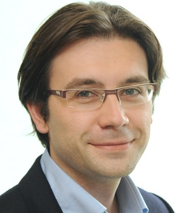
Donato Teutonico has received his PharmD from the University of Turin, Italy, where he specialized in chemical and pharmaceutical technology, and his PhD in pharmaceutical sciences from Paris-South University, France. He has 14 years of experience in modeling and simulation of drug effects and clinical trials in industrial and academic settings. Donato has authored 2 books, 2 book chapters and contributed to more than 13 publications in international journals. He is currently PBPK Scientific Expert at Sanofi.

Maïlys De Sousa Mendes (Certara)
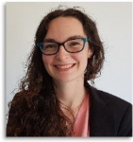
Maïlys De Sousa Mendes is an Associate Principal Scientist who joined Simcyp in 2016.
During her PhD, she focused on Physiologically Based Pharmacokinetic (PBPK) modeling of transplacental drug transfer. This work involved incorporating ex vivo data from perfused cotyledon models into the PBPK framework.
At Simcyp, Maïlys contributes to several key areas of platform development, including developing and updating compound files, qualifying the Simcyp platform and implementing new mechanistic features, such as pathway mass balance, back-conversion, and time-dependent volume of distribution.
She is an active member of the Transporter Team, where her responsibilities include improving the in vitro-in vivo extrapolation (IVIVE) of transporters and their subsequent qualification within the Simcyp Simulator.

Maxime Le Merdy (Simulations Plus)
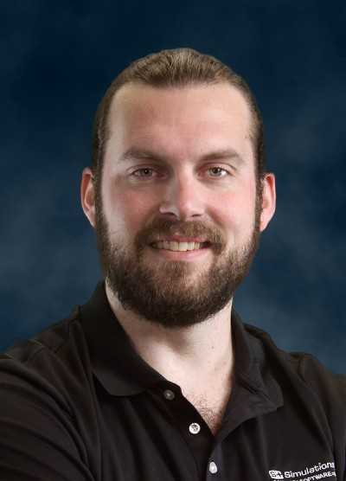
Dr. Le Merdy serves as the Director, Scientific Product Enablement at Simulations Plus, a global leader in innovative modeling and simulation software for pharmaceutical research and development.
He earned his Pharm.D. from Paris University in 2015 and completed his Ph.D. in 2022. In 2017, Dr. Le Merdy joined the U.S. Food and Drug Administration (FDA) as a postdoctoral fellow in the Division of Quantitative Methods and Modeling within the Office of Generic Drugs. During his time at the FDA, he specialized in physiologically based pharmacokinetic (PBPK) modeling for locally acting drug products, contributing to the advancement of non-oral PBPK methodologies and publishing several papers in this domain.

Fiona Plait (Simulations Plus)
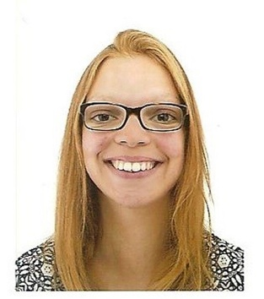
Fiona Plait is a scientific Product Specialist at Simulations Plus, a global leader in innovative modeling and simulation software for pharmaceutical research and development. She joined the company in 2023.
She earned her Pharm.D. from Paris University in 2020, and her master's degree in Pharmacokinetics from the same university in 2019.
She has 6+ years of experience in PBPK modeling: she worked at UCB Pharma as a PBPK modeler and at Parexel where she helped develop PK studies and PBPK models.

Xavier Pépin (Simulations Plus)
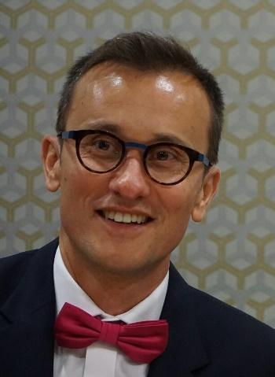
Xavier Pepin is VP PBPK R&D at Simulations Plus. He joined the company in 2022.
He is a pharmacist (University Paris XI). He has a Ph.D. in granulation technology where he studied powder surface energy and liquid bridges during wet high-shear granulation. He has 25 years’ experience in the pharmaceutical industry and has occupied several positions from pre-formulation, clinical and commercial formulation development, industrial transfer, regulatory CMC and biopharmaceutics. He’s worked in biopharmaceutics for 15 years using in vitro, in silico, and in vivo tools to support evaluation of drugs along the development value chain and post marketing.
He has 60+ publications in the field of powder surface energy, granulation technology and biopharmaceutics modeling and simulation

Carla Troisi (ESQlabs)
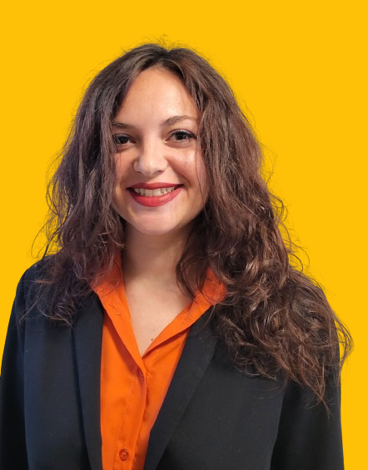
Carla Troisi is a Systems Pharmacology Scientist at ESQlabs, a consulting company specializing in PBPK and QSP modeling and simulation to support R&D decisions across the pharmaceutical, chemical and crop protection industries. She has been working since 2024 on PBPK modeling with a focus on large molecules.
She holds a Master's degree in Pharmacometry/Pharmacokinetics from the Faculty of Pharmacy of Marseille, and a PhD in Pharmacology from the University of Bologna. Her doctoral research focused on population PK/PD and time-to-event modeling of antibiotics and inflammatory biomarkers in critically ill patients. Before that, she studied the PBPK modeling of monoclonal antibodies for cross-species extrapolation at Sanofi, and gained some experience on machine learning approaches for model-informed precision dosing at InsightRX (San Francisco).
She is also a board member of the GMP.

